

WMS Hawk Football
2025 8th Grade Wyandot Middle School Football
Coaches
Football is a no-cut sport. There are no try-outs or players who won’t make the team. If you want to participate, follow the information/expectations explained here and you are on the team.
Anthony Moceri : amoceri@cvs.k12.mi.us
Sal Giacalone: sal.giacalone@gmail.com
What You Will Need This Year
- Physical form (dated after April 15, 2025)
- Football Cleats - Combination Lock - Water for practice every day
- Mouthguard (one standard guard provided, but if you want your own fitted/fancy one)
- Transportation home from practice at 5PM (we provide transportation to and from games)
The Wyandot Football Program Will Provide The Following
- Helmet
- Shoulder pads
- Game uniform – pants and a jersey
- Practice gear – pants and a jersey
All of these things will be turned back in at the conclusion of the season. If you would like to get your own equipment (helmet, shoulder pads, pants, etc.) you are welcome to do so. Just have a coach inspect it for size/safety before you wear in a practice or game.
Pre-Season Schedule – All Practices (Pre- and In-Season) will be from 3-5:00 PM)
Monday August 25 | Tuesday August 26 | Wednesday 8/27 | Thursday 8/28 | Friday 8/29
Pick Up Equipment @ 3PM  Practice 330-5 PM | Practice 3-5 PM  Helmets only | Practice 3-5 PM  Helmets Only | No Practice | No Practice

Monday Sept. 1 | Tuesday Sept 2. | Wednesday 9/3 | Thursday 9/4 | Friday 9/5
Labor Day  No School/Practice | 1st Day of School  ½ Day, No Practice | Practice 3-5 PM  Helmets+Shoulders | Practice 3-5 PM  Helmets+Shoulders | Practice 3-5 PM  1st Day FULL PADS

*After school begins, we practice Monday to Friday from 3-5 PM, with a scrimmage on Tuesday Sept 9.*
Games begin Tuesday, September 16, and always take place on Tuesdays. A schedule is attached.
Team Expectations
- Attend practice every day. This is essential to learning the game, the playbook, continual improvement, and team collaboration.

- Show up to the first week of practice IN SHAPE. Exercise and stay active over the summer.

- Be on the field on time every day for warm-ups (approx. 3:00-3:05)

- If you need to be absent, please notify a coach by email, Schoology message, Remind, or through a team mate you trust to deliver the message. Unexcused absences from practice will result in the loss of playing time (i.e., One missed practice = 1 missed quarter of play, two missed practices = game ineligible)

Advance notice with reasonable justification is required for an absence to be considered excused.

- Everyone will play in the game; how much will be determined by you.

  - Class work
  - Behavior
  - Attendance
  - Effort
  - Ability
  - Know the plays!

- Listen to your coaches and be willing to sacrifice for the team

- Conduct yourself appropriately and put forth your best effort in the classroom. Football players are student-athletes, with student coming first.
Parent Information
- All players must have a physical form completed by a physician dated after April 15, 2024, in order to begin practicing. This physical will be good for all 2024/25 sports.
- Coaches will receive eligibility reports from teachers on a weekly basis. Students will be eligible with satisfactory reports in academics and behavior. If a student receives an unsatisfactory mark, they will be put on probation. Unsatisfactory marks in the same class for two consecutive weeks will result in the student missing one game.
- There will be a parent meeting early in the season after practice. Details will follow on date, time, and location. It will take place at the end of practice in the stands/bleachers.
- We are always in need of parent volunteers for the chains and yard marker for home games. If you are interested in volunteering, please contact Coach Moceri or our athletic director, Mr. Bickers.
- For any parent complaints or concerns, please use the 24-hour rule. Please wait 24 hours before contacting a coach.
If you have any questions or concerns, please feel free to contact me at any time.
Anthony Moceri – Head Coach (586) 723-4278 or amoceri@cvs.k12.mi.us
Brian Bickers- Wyandot Athletic Coordinator (586) 723-4247 bbickers@cvs.k12.mi.us

Player and Parent Communication
The WMS 8th grade football team will be using the Remind app/service to communicate important dates, information, and messages to players and parents. Below are examples of reasons I would send a Remind message:
- Changes/updates to a game or practice schedule
- Information about the location of our games (directions, which field to go to, bring a chair, etc.)
- Game or practice updates based on weather (cancellation or delay due to storms)
- Important events (picture day, first day of practice, turn in equipment, etc.)
- Two-way messaging with players and parents, seeking volunteers for home games, etc.
It is important that both players and parents sign up for this service to receive updates. Use the directions below, or from the WMS football website (through CVS homepage > Wyandot MS) to sign up.
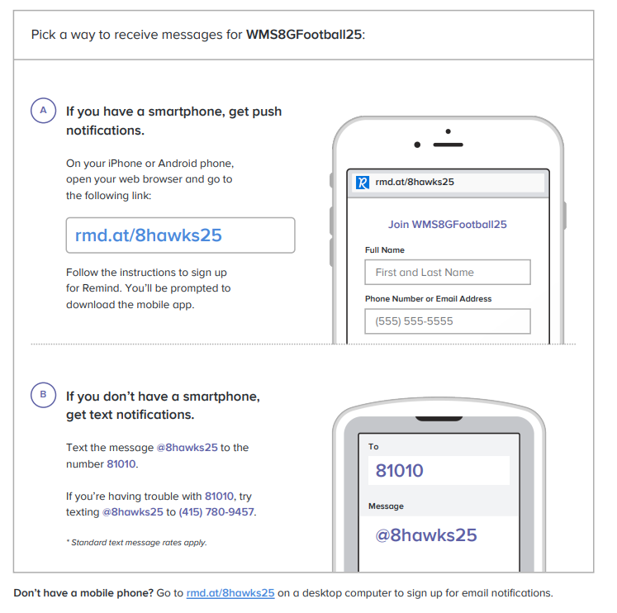
WMS Hawks Football

2025 Wyandot Middle School Football

Date Opponent Site/Location
Tues., Sept. 9 Scrimmage (Algonquin) Algonquin
Tues., Sept. 16 Romeo Middle School Romeo High School
Tues., Sept. 23 Lanse Creuse East Wyandot
Tues., Sept 30 Lanse Creuse Central LCC
Tues., Oct. 7 Richards Middle School Wyandot
Tues., Oct. 14 Lanse Creuse North LCN
Tues., Oct. 21 Bemis Junior High Wyandot

7th Grade games start at 3:30 pm
8th Grade games follow 7th grade (usually around 430-445, but can vary)

