HAWK Fest
Dance / Dodgeball / Open Gym
(Have a positive attitude, Always respect self, others and property, Work hard to reach your highest protentional, Keep our school and other safe)
Who:
Students that have shown HAWK Behaviors

Guidelines:
~ Do not currently have an N or U for citizenship.
~ No suspensions from January 10th-February 10th.
~ Have not received 2 or more steps in one hour.
~ Have fewer than TEN TOTAL tardies from January 10th-February 10th.
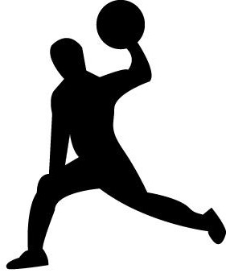
When:
February 10th, 2023
6th Grade 5th Hour
7th Grade 4th Hour
8th Grade 6th Hour
Why:
To celebrate all the positive and responsible choices our Wyandot students have made.
Cost:
A smile, thank you, and HAWK behaviors!

