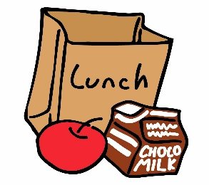
Food Service
This Photo by Unknown Author is licensed under CC BY-NC-ND
Meal Distribution

FREE Breakfast/Lunch is available for
ALL Chippewa Valley Students

Beginning Friday, January 22, 2021:
Weekly food pick-up is available on Friday’s
11:00 AM – 1:00 PM at the following locations:

Cheyenne Elementary - Door # 6
47600 Heydenreich, Macomb
Huron Elementary - Door # 37
15800 Terra Bella, Clinton Twp.
Iroquois Middle School- Door # 8
48301 Romeo Plank Rd., Macomb
Clinton Valley Elementary- Door # 10
1260 Mulberry, Mt. Clemens

Multiple meals for virtual learning days will be distributed at the above locations for all students 18 and under. All meals are FREE. Parent/Guardian will be asked to provide student’s group (hybrid or CVVA) when picking up meals.
Distribution will not take place during holiday breaks.

To see if your family qualifies for additional benefits,
please fill out a free/reduced application at www.lunchapp.com

